Pomegranate Seeds Moroccan Style
http://moroccanfood.about.com/od/dessertsandcookies/r/pomegr_dessert.htm
By Christine Benlafquih, About.com Guide
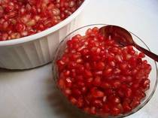
Pomegranate seeds
Photo © Christine Benlafquih

Pomegranate seeds are juicy, nutritious, and extra delicious with the Moroccan additions of orange flower water and cinnamon. Moroccans are most likely to serve this tasty treat as a dessert, but my kids are happy to snack on a bowlful any time!
Also try Moroccan Pomegranate Juice.
Prep Time: 20 minutes
Total Time: 20 minutes
Ingredients:
- 4 pomegranates
- 3 tablespoons sugar
- 2 tablespoons orange flower water
- cinnamon
Preparation:
Seed the pomegranates. Wash the seeds, and leave to drain.
Mix the pomegranate seeds with the sugar and orange flower water. Serve in bowls with cinnamon on the side to sprinkle on as a garnish.
Pomegranate seeds can be stored in the refrigerator for two days in an airtight container.

