The Churchies’ year 2011.


Following a quiet new-year meal with friends John and Lynn we entered what looked to be the terminal throes for One World and Fair Trade in Hull. However, the turning point was a consultation exercise held near the end of January and as a result we entered into negotiations to pass the business over to Nigel Mills and his team at the Hull and East Yorkshire Community. By June we were committed but it still took a while before we could complete the legal process. Fair Trade in the area, now has new owners, new blood, new life, and new hope, but it still needs more customers.
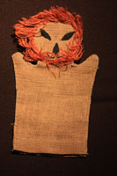
As I write this, it is 30 years less a couple of weeks since Mick gave Ross the Lion Hand Puppet, and we asked where it had been bought. (Traidcraft). There have been many joys and sorrows and plenty of aching backs and furrowed brows along our Fair Trade journey. Suffice to say that we have met many wonderful people, shared some truly memorable moments. More importantly our involvement in Fair Trade with the support of the Methodists at Central Hall, unstinting support from volunteers and agents in Hull and the surrounding counties led to over £1 million in Fair Trade sales, and whilst we may never meet the people to whom this made the greatest difference, we do share just One World.
What else to tell?
Ross is still based in Lund in Sweden and hosted a parental visitation in the middle of the year. We fell in love with Sweden and Stockholm in particular. Ross seems well employed (almost overworked) within his group but as with all post doc work, funding is a recurring issue that will comes up again before long.
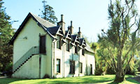
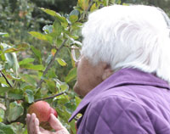
We did also have a few days camping in the dales and a couple of trips to Brackenborough with “G”. And as proof that we are officially getting soft, an apartment was rented in Kintyre for a week.
Luke registered his company in the middle of the year so that he could be paid properly for helping people with making better software. He seems to spend half of his time in Singapore, half in America, half on an aeroplane, and half in Cambridge (I know that doesn’t add up, but Luke seems to be able to run along the high-wire of life without stopping).
We discovered Simon Garfield and mass observation during the Humber Mouth literature festival, and Chris is now heavily into writing a play about the immediate post war period. Peter is improving his genealogical research and has put most of the output on t’internet at www.crimlisk.org.uk – have a look.
The year has been punctuated by some very memorable meals. Taking the incredible WoZ as inspiration, and happiness is Fun x Food x Friends, we have explored Greek and Italian, Swedish and Moroccan, and held a home-made bread fest.
Real bread! It has flavour, aroma, nutrition, texture and is just great. And it is about half of the cost of shop-bought machine made stuff, and even less than a quarter of the price of a handmade organic loaf in a shop. But don’t forget to add that little bit of salt to the dough, it’s just wrong without it.
Anyway, enough, retirement beckons, there’s a decorating backlog, junk to recycle, books that should have been read yonks ago, beaches to visit, and the birds to feed. All summer long we had goldfinches in threes and fours. Come the winter and they have turned up mob-handed, 10 to 15 in the flock, and not one of them with any table manners. We also occasionally see a greater spotted woodpecker trying to extract insects from the upright stand of the bird table.
With best wishes for a happy Christmas and a healthy and prosperous 2012.

Chris, Pete, Ross and Luke.

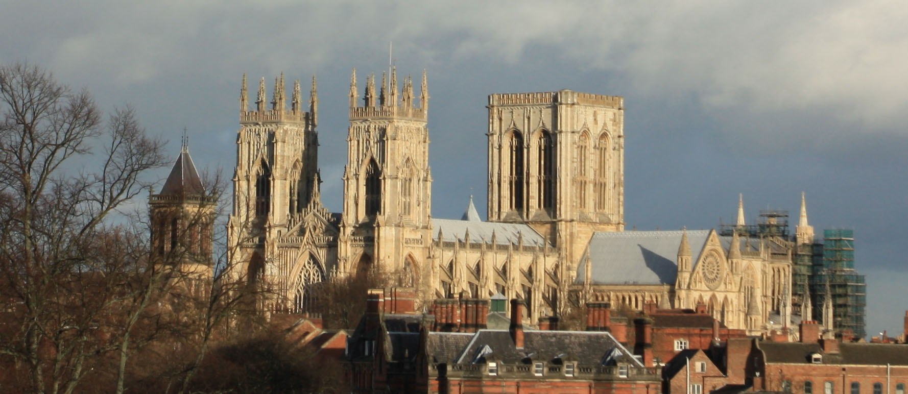
York Minster from the City Walls.
For more pictures, stories, and the family tree (well jungle), visit www.pchurch.org.uk/church/index.htm

