DATING OLD PHOTOGRAPHS -
A SYSTEMATIC APPROACH

The Object is to devise a system for dating photographs based on original data collected by the learner’s for the purpose. Both physical properties and content will be considered.

The key research areas

Format | CDV | Corners, bamboo, print density on back. Card printer
Format | Cabinet
Format | Postcard
Format | Snapshot
Medium | Paper
Medium | Paper on Card
Medium | Glass
Medium | Iron
Medium | Brass
Process | Daguerreotype
Process | Ferrotype
Process | Ambrotype
Process | Colour
Pose | Head to foot
Pose | No Foot
Pose | Head
Studio | Back drop elements | Drape, column, rustic
Fashion | Skirt length on or off the ground
 | Leg of Mutton sleeve
 | Bustle
 | Choker | With broach
 | Ruff
 | Wasp waist
 | Jacket | Buttons. points
 | Bodice | Cuirass
 | Blouse & Skirt
Hair | Are a lady’s ears visible

Data will be gathered for the appropriate periods between 1850 and 1920 with full bibliographic and resource details provided

The data will be presented initially in the following manner:

Feature
Year | No of obs
1850 | 1
1851 | 2
1852 | 10
1853 | 9
1854 | 5
1855 | 4
1856 | 3
1857 | 2
1858 | 1
Min |  | 1850
Q1 | 2 | 1851
Median | 3 | 1852
Q3 | 5 | 1854
Max |  | 1858
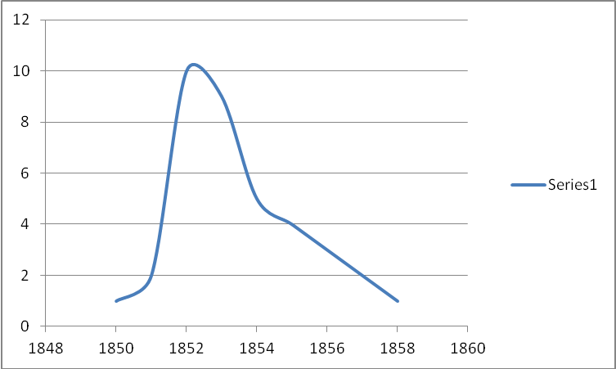

The findings will be displayed as either:

- A timeline
- Flow chart
Or if time and expertise permits, then a computer based version will be considered.

This project will be assessed and will replace the extended writing to a value of 1000 words. The data collection and presentation will count for 500 words and the balance will be a reflective piece about the project touching on methods, resources, techniques, analysis, evaluation, outcome, practical application, comparison with other photo-dating models achievement etc.

Some web based resources:

