‘Skegness’ H14
Posted on “Looking at Filey” September 24, 2011
The Hull trawler Skegness was built for the Admiralty in 1917 and, as James Peake, undertook anti-submarine duties. The vessel was re-named Aragonite in 1924 andSkegness in May 1934 when she was purchased by Trident Fishing Company of Hull. Just over a year later, returning full of fish from the Faroe grounds, the vessel ran onto rocks beneath Speeton/Bempton cliffs at night and in fog. The weather was quite calm and Skipper Richard WRIGHT, age 28, didn’t send out an immediate call for help, believing he could refloat on the high tide. He declined a tow from ST Nordale SH89.
These proved to be fatal errors of judgement. A fierce gale sprang up that defeated every subsequent effort by lifeboat and rocket brigade to reach the vessel. For a while the helpless rescuers on the cliffs could hear the cries of the fishermen above the roar of wind and sea. The crew then took shelter in the wheelhouse signalling hopelessly for a while by flashlight and radio.
Arthur COLEMAN was lead man of the Speeton Rocket Brigade and his son, Chris, told what he remembered of that night in an interview given during the Exploring Filey’s Pastproject (Crimlisk Fisher Archive). Chris was five years old but, he said,
what I can remember was the most awful banging on our cottage door and somebody shouting for father to get up because there was a ship ashore…
…So about half past two the following morning, early in the morning, er, the 25th of September 1935, the funnel crashed over the wheelhouse and all lives were lost. And the following morning I can remember being in our cottage at home and the old beastman was first man to come home from the wreck of the Skegness. Nobody knew what was going on, no communications whatsoever, he was the first man to come back from the wreck and he sat in our cottage and my mother got him some tea and he had to milk the cow and then he said, I’ll have to go back and take the men some food and drink and that’s the only thing they got and they were stood on the cliff top shivering and freezing and nothing till old Henry Townsend walked all the way back again. And news of the wreck and the disaster came through very, very slowly, no communication whatsoever on the cliff top. And of course all the coastguard lights blew out, they had acetylene lamps and the only lamp that survived was my father’s stable lamp and he stood at the cliff top just waving it down to the wreck.
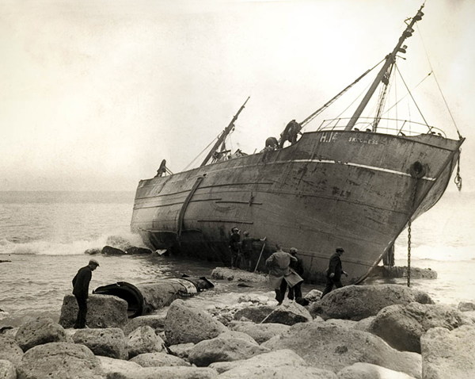Photographer unknown, 26 Sep 1935, courtesy Francis R Jenkinson
There are several online accounts of the loss of Skegness and her crew, three of them on the Filey Bay Initiative website by Lee Norgate and A. Green plus an Underwater Survey of the wreck with photos by John Adams.
A search for a contemporary newspaper account online took me to the other side of the world and the amazing Trove. Digital Britain redeems itself somewhat with a brief Pathé news clip. (It’s the third story featured.)
One of the men lost in this tragedy was from a Filey family. Joseph L. CRIMLIS, born 1916, was the son of Tom CRIMLIS and Una Gladys CLUBLEY and great great grandson of Thomas CRIMLISK the Coastguard from Ardara, County Donegal. (In January 1940 Ronald CRIMLIS, Joseph’s younger brother, was lost from HMT Kingston Cornelianwhilst on anti-submarine service in the Mediterranean.)

Published by kind permission of Ian Elsom.

