Inquest open after death of volunteer

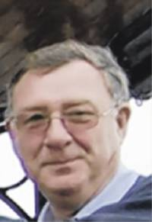
Graham Crimlisk - 2008
Photograph courtesy Penny Crimlisk.

The Filey Mercury: Published: 30 January 2010

An inquest has been opened and adjourned following the unexpected death of a 62-year-old Filey volunteer. Graham Crimlisk had been a volunteer driver and trustee for the Good Neighbours Coastal Car Scheme, which works in partnership with Dial-a-Ride to help elderly and disabled residents get around.
He was also a keen golfer who was well known at Filey Golf Club where he played about four times a week.
He and his wife Penny recently celebrated their 40th wedding anniversary, and Mrs Crimlisk said his death at home on January 21 had come as a great shock to everyone.
Until recent problems with his knee, Mr Crimlisk had enjoyed good health and fitness, walking 20 miles-plus on the golf course every week, according to his wife.
Born in Filey, Mr Crimlisk left the town at 11 when his father got a new job, but he always lived near the Yorkshire coast and moved back to Filey with his wife in 1980.
The couple met on a bus when Penny, from Malton, was going to secretarial school in York and Mr Crimlisk was at the technical college.
He was involved in the construction business and worked at Wards of Sherburn for 28 years.
Mrs Crimlisk said: "He was a quiet person, but he did have strong views. He really enjoyed doing his volunteering for the coastal car scheme, and he had 'regulars' he would take from places like Chapel Court in Filey to Morrison's."
Mr Crimlisk also leaves a daughter and two granddaughters.
A funeral service was held at St Oswald's Church in Filey yesterday, with donations to be shared between Filey Lions Club and Filey Salvation Army.
--o0oo—

