Andrew Marvell
Business & Enterprise College
Fairtrade coffee at morning break on
Wednesday 14th March 2006
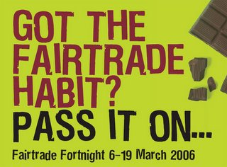

All staff are invited to sample Fairtrade tea, coffee, biscuits and chocolate cake which will be placed in Barham and Jervis staff rooms for Wednesday break.

All students have been invited to take part in a word search competition , closing date Thursday 16th March. Winners will be drawn on Friday 17th March.
Prizes include Fairtrade footballs and Fairtrade chocolate bars.

