Fairtrade Fortnight in Hull, and PaPaPaa DVD.

In the Shop

The PapaPaa DVD was in almost continuous use.
During the first week we had a rolling display in the One World Shop. This attracted plenty of attention and interest. We had 3 or 4 seats around a table in the shop with the computer display and a good variety of people watched the DVD and some interesting questions arose from this. It is hard to quantify how many people we reached as we did not keep any records, and no single individual was there throughout.

Private Events

On Wednesday 6th we did a DVD presentation and chocolate tasting at Sewerby Methodist circuit. We had about 25 people there. We showed the DVD in two stages Cocoa growing and Chocolate making then a break for tasting, and then whilst people were milling round the remainder of the DVD was shown. Without any prompting, people sat and watched. At the end of the session the local “activist” purchased the DVD and photo pack from me for use in the circuit.

The DVD was shown to about 65 people at a Fairtrade Fun Night on Tuesday 14th at the Endsleigh Centre.

Public events.

From Saturday 11th through to Saturday 18th the DVD was shown on the big screen in Hull. Two 15 minute sections of the DVD were shown each hour 24 hours a day for the week. It is difficult to know how many people we reached but I think it is fair to say that several thousand people will have seen the DVD based upon the figures below just for the tasting event on Saturday the 18th.

On Saturday 18th we had a Day Chocolate and Co-op sponsored food tasting session in Queen Victoria Square underneath the big screen.
(Martin Budd left, screen, awning on right with Chris Church in white coat clutching a hot cup of Fairtrade coffee).
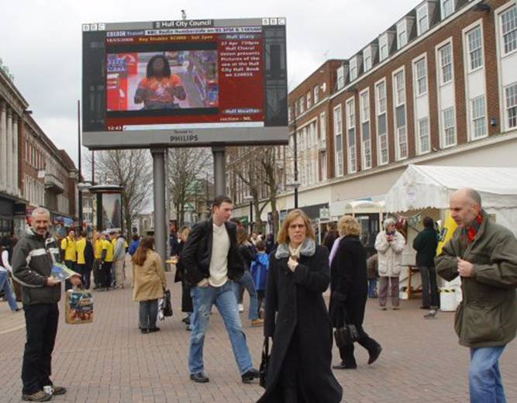

Day Chocolate was offered by Martin Budd approaching people in the square (note decorated carrier bag containing Darkly Divine).
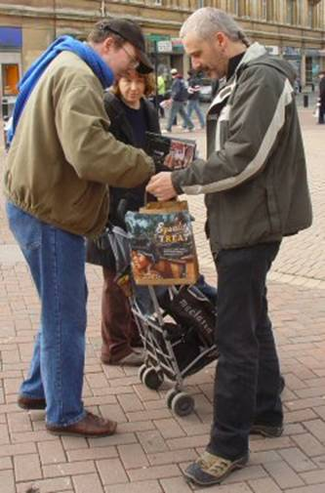

The Co-op food was provided under cover.
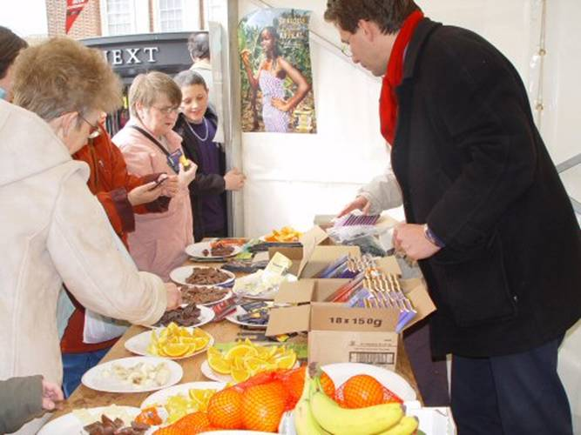
People supporting this included a Cabinet member from Hull City Council, a Board Member of Northern Co-op, Directors and staff of the One World Shop, and the MP for Hull North (Diana Johnson), as well as other Fairtrade City activists.
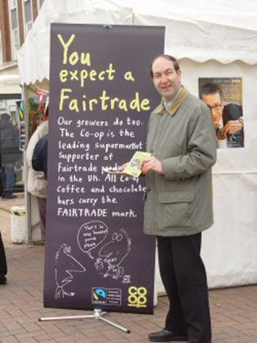
The Co-op chocolate was very popular and people were receptive to the fact that it is Ghanaian cocoa in both Co-op chocolate and Divine chocolate. The conjunction of the big screen and the tasting session, together with ample supplies of the new Guide to Fair Trade in Hull (we started with 10,000 copies) and reinforced by the personal approach was very effective at getting through to people in spite of the somewhat chilly weather. We gave out about 1,000 copies of the guide, so we probably reached roughly that number of people.

An interesting even if subjective observation, is that the majority of people now said that they had heard of Fairtrade (and they were not just saying that to get a piece of chocolate) because they said where there awareness had come from. Many school age people were exposed to the idea via RE or Citizenship or geography, many through church, and interestingly many through the national advertising during FT Fortnight.

Immediate futures

In the near future we are running a full day training session for Hull Development Education Centre staff who will in turn be delivering workshops on chocolate to 14 youth groups in East Yorkshire. The workshops will include the use of the PaPaPaa DVD.

[end]

