

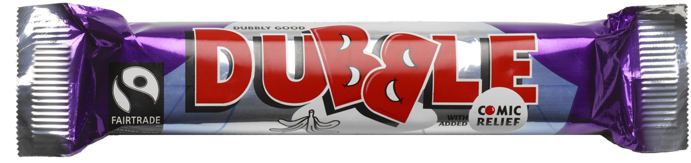


CHOCOL-8: THE COCOA SUMMITS

In June 2006 young people all over the UK will come together to change the world, chunk by chunk!

Chocolate is the UK’s favourite treat and is loved all over the world, but life is not always sweet for cocoa farmers. Like so many farmers in developing countries, cocoa farmers often don’t earn enough to make a decent living for their families. Choosing to buy Fairtrade products is a simple but powerful way that chocolate lovers can already make a difference and guarantee farmers a fair deal. The CHOCOL-8 Summits are about exploring what else needs to be done to make the chocolate world a sweeter deal for cocoa farmers.

Delegates will unwrap the story behind the chocolate chain and explore the issues surrounding this huge global industry. They will get the chance to meet young people from Ghanaian cocoa farming communities, to learn first hand what life is like for cocoa farming families and share each other’s visions for the future.

By the end of the summits, delegates will be ready and inspired to campaign for a better deal for cocoa farmers and for other developing country producers too.

The CHOCOL-8 Challenge…

By the end of each CHOCOL-8 Summit delegates will come up with their very own ‘Chocolate Challenge’ manifesto to decision makers, governments, chocolate lovers and industry to make the chocolate industry a sweeter deal for everyone. The CHOCOL-8 Challenge will be presented to government and industry representatives at the end of the summit series by a delegation of eight young people from the UK and Ghana. Young people will make their pledges to choose Fairtrade and take action, and they will ask decision makers and industry to join them in working towards a better future for cocoa farmers.
50,000 already campaigning!

Over 50,000 young people have already signed up to be Dubble Agents and change the world though Fairtrade. Thousands of teachers have used the ‘Pa Pa Paa’ teaching resources produced by Dubble and Comic Relief. The Chocolate Summits will mobilise this huge active network of young people and teachers who want to see change.
www.dubble.co.uk www.papapaa.org

Where and When?
CHOCOL-8 LAUNCH: The Hay Festival, Hay-On-Wye, 30th May
CHOCOL-8 ONE: Liverpool, 5th June
CHOCOL-8 TWO: Hull, 7th June
CHOCOL-8 THREE: London, 9th June
THE CHOCOL-8 CHALLENGE: Early June. The CHOCOL-8 delegates will present their manifesto to decision makers and chocolate industry representatives
GLOBAL CHOCOL-8: Global Village, Maidstone, Kent , 29th July-9th August

For more information please contact Louise Mollring, Trading Visions: louise@tradingvisions.org ,Tel: 020 7378 6550
Trading Visions is a pioneering new charity, established out of the popular Fairtrade education work undertaken by Day Chocolate, Comic Relief and Kuapa Kokoo cocoa co-operative since 1999. The Chocolate Summits follow on from the latest ‘Pa Pa Paa’ teaching materials produced by Trading Visions and Comic Relief. See www.papapaa.org,

