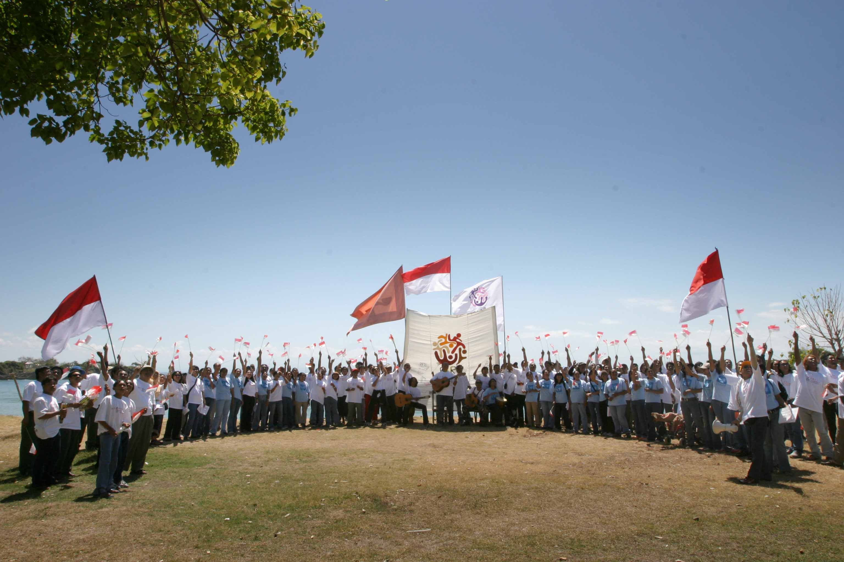
GLOBAL JOURNEY UK

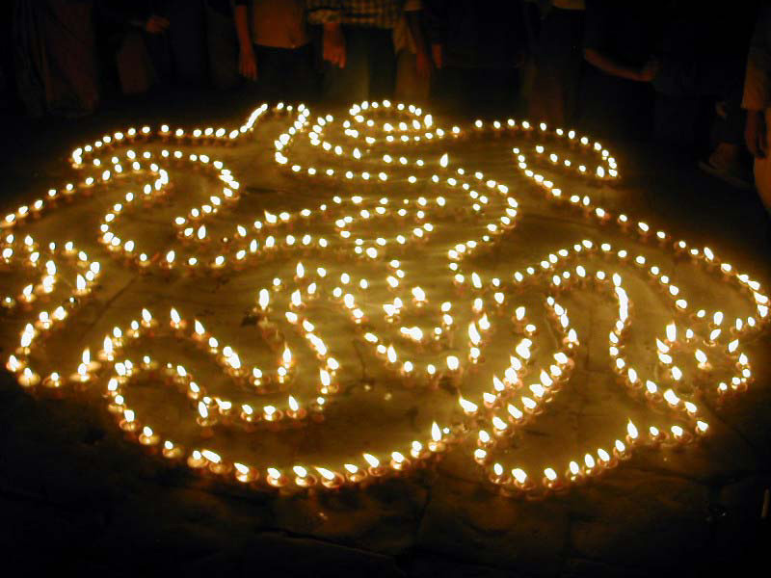

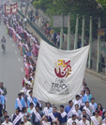
IFAT's Fair Trade Organization Mark (FTO Mark) is on a world tour! The Global Journey is the procession of the official FTO banner and message around the world. The Journey was launched at the World Social Forum in Mumbai and to date has travelled through
Asia,
South America, North America, Africa and Australasia.

Global Journey Nepal

IFAT

The International

Fair Trade Association
IFAT is the global network of Fair Trade Organisations. IFAT’s mission is to improve the livelihoods and well being of disadvantaged producers by linking and promoting Fair Trade Organisations and speak out for greater justice in World Trade.
In each country IFAT members and Fair Trade supporters have organized events to publicly announce and celebrate Fair Trade Organizations, Fair trade and the Fair Trade Organization Mark.
The banner, which carries the symbol for the FAIR TRADE ORGANIZATIONS, identifies groups that have Fair Trade at the heart of what they do and believe in - and they have met the standards and monitoring criteria of IFAT.

The European tour started in Malta on 4th June then moved to Strasbourg. It will then cross to the Netherlands, Sweden, Paris for the IFAT
European conference, Switzerland, NEWS conference

in Bolzano, Spain, France Switzerland, before landing with us in the UK from March 2007.

FTOs from England, Scotland and Wales will be working with BAFTS members, Fair Trade Cities, Church Groups and individuals to make the Global Journey UK happen.
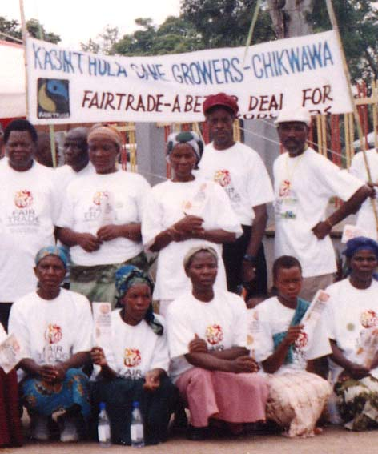

Global Journey Malawi

CALENDER OF EVENTS

This is where YOU all come in, the Global Journey is an excellent opportunity to: promote Fair Trade, Fair Trade Organizations and to show solidarity with the world wide Fair Trade movement.

Here are the dates that have already been booked with contact details. You are invited to join these events or add your own event.

3RD – 4TH March GLASGOW THE FAIR TRADE EXPERIENCE EVENT: Visit the IFAT stand and see the presentation on the Global Journey and join Global Journey procession around the event.

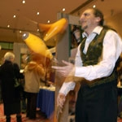
The 07 Fair Trade Experience is being hosted by Hand Up Media on Saturday 3rd and Sunday 4th March 2007 at the Glasgow Royal Concert Hall. Enjoy two days of Fair Trade & ethical shopping experience under one roof, get lots of information, enjoy a wealth of live music & entertainment for kids, young and old and hear & engage with Fair Trade speakers from around the world, and maybe some surprise guests...

For more information or to book a stall contact tania@handupmedia.co.uk or 05600 755 015

March: (dates to be set)
THE ONE WORLD SHOP EDINBURGH
EVENT: The Global Journey banner to be piped down the Royal Mile. Supported by the Scottish FTOs . The event is to be finalized after the September meeting.

CONTACT: Rachel on rfarey@oneworldshop.co.uk or 0131 229 4541

Fair Trade recognizes cultural diversity and The Global Journey is keen to promote using traditional costume, instruments of the regions it visits, so get those kilts on!

INTERESTED IN HOLDING AN EVENT?
PLEASE SEE THE MAP ON THE NEXT PAGE TO SEE WHEN THE GLOBAL JOURNEY IS IN YOUR AREA.
CONTACT KATE MEAKIN AT UKGLOBALJOURNEY@YAHOO.CO.UK
OR RING 07840 485344

14th April
IRELAND
EVENT: An event will be put on to celebrate the Global Journey.

20th April
YORK
EVENT: FAIR TRADE event in York School, with possible inclusion Archbishop Sentamu.

CONTACT: Jeremy at JP@sharedearth.co.uk
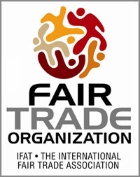

The Global Journey banner is a great focal point to create discussion and learning of Fair Trade. Especially as this can be tied in with where the banner has already traveled to.
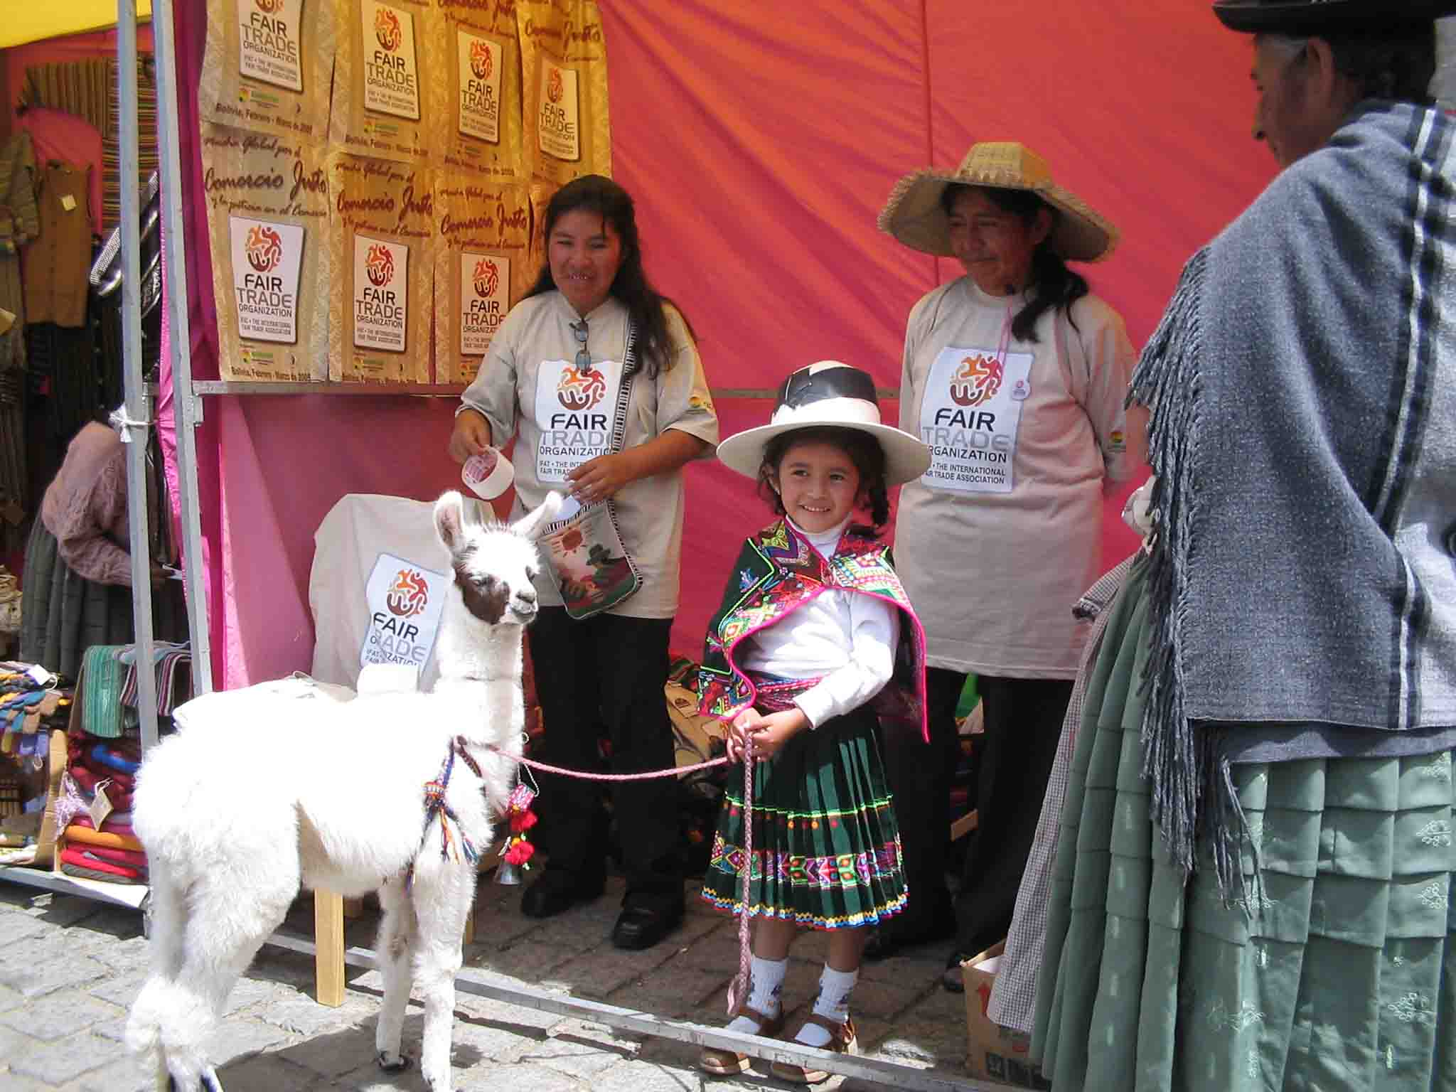
Global Journey in Bolivia

21st APRIL
HULL
EVENT: There will be a march from One World Shop to the Guildhall, to the Institute for abolition of slavery. The speech will be read in Queens garden or outside the law courts

CONTACT: Peter at peter@fairtradehull.org.uk

28th – 29th April
OXFORD
EVENT: Service at the Oxford University church, the Global Journey will be welcomed by one of the first Oxfam field directors in South India. A street play outside the Fair Trade Shop in the Cornmarket and Fair Trade coffee in the Vaults. The banner will then move on to Banbury.
CONTACT: Carol at
cwills@oxfordhr.co.uk
3/03
Early May: (Dates to be finalised)
WALES
EVENT: Three events are being planned in: South, Mid and North Wales to promote the Global Journey. The big debate at Cardiff University ‘Fair Trade V Free Trade’. The banner may be transported round Wales on the top of a vintage bus. Plans to get the banner it to the top of Mount Snowden!
05/05
CONTACT: Kate at ukglobaljourney@yahoo.co.uk 07840 485344

5th May
CARDIFF
EVENT: There will be a fashion show put on by Fairdo’s and Oyster at the Gate Art’s Centre, This will
include a talk on the FTO Mark. The banner will be used on the run way. Plans may include a world choir to sing it on its way

CONTACT: Jan at jtucker@fairdos.com 02920 759802

To get media attention make your event as eye catching or unusual as possible. Brain storm your ideas, Kate is here to help!

Below is an idea of when the banner will be passing through your area.
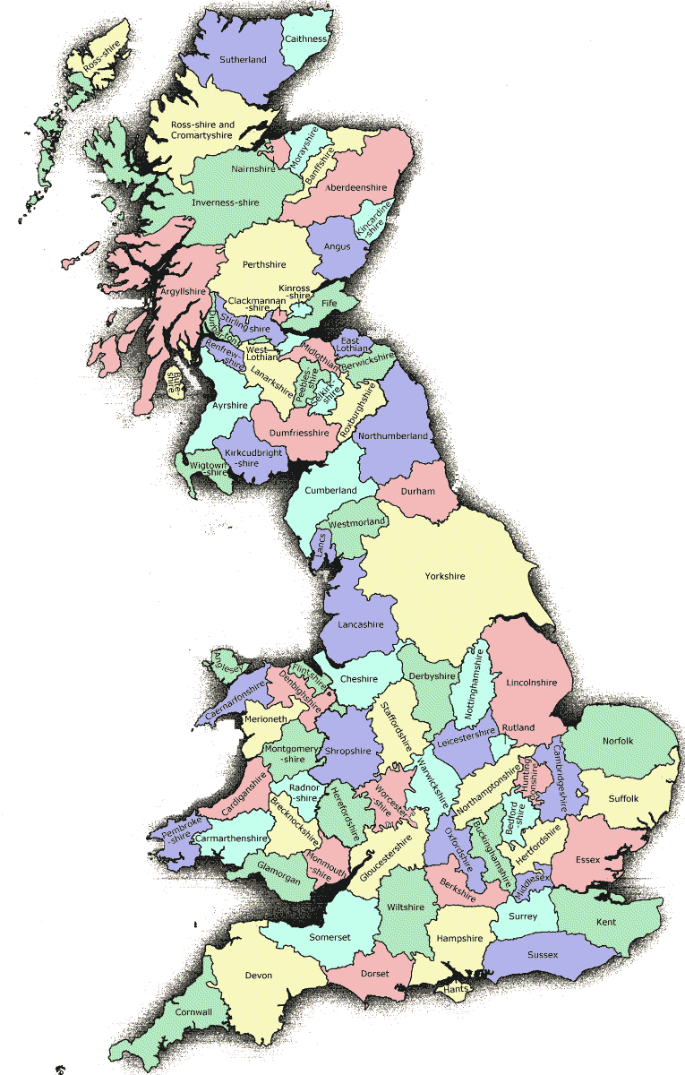
LONDON: (date to be confirmed)
EVENT: A joint event is being planned with the FTOs; the proposal is currently being written and costed for this attention grabbing campaign. Ideas so far include: a rally, rickshaws, a boat down the Thames and a red open top London bus, persuading politicians and journalists to come on board and discuss FTO’s. There is also discussion about holding another Free Trade V Fair Trade debate.
CONTACT: Kate at ukglobaljourney@yahoo.co.uk

The Global Journey has 5 costumes available that make up the FTO symbol
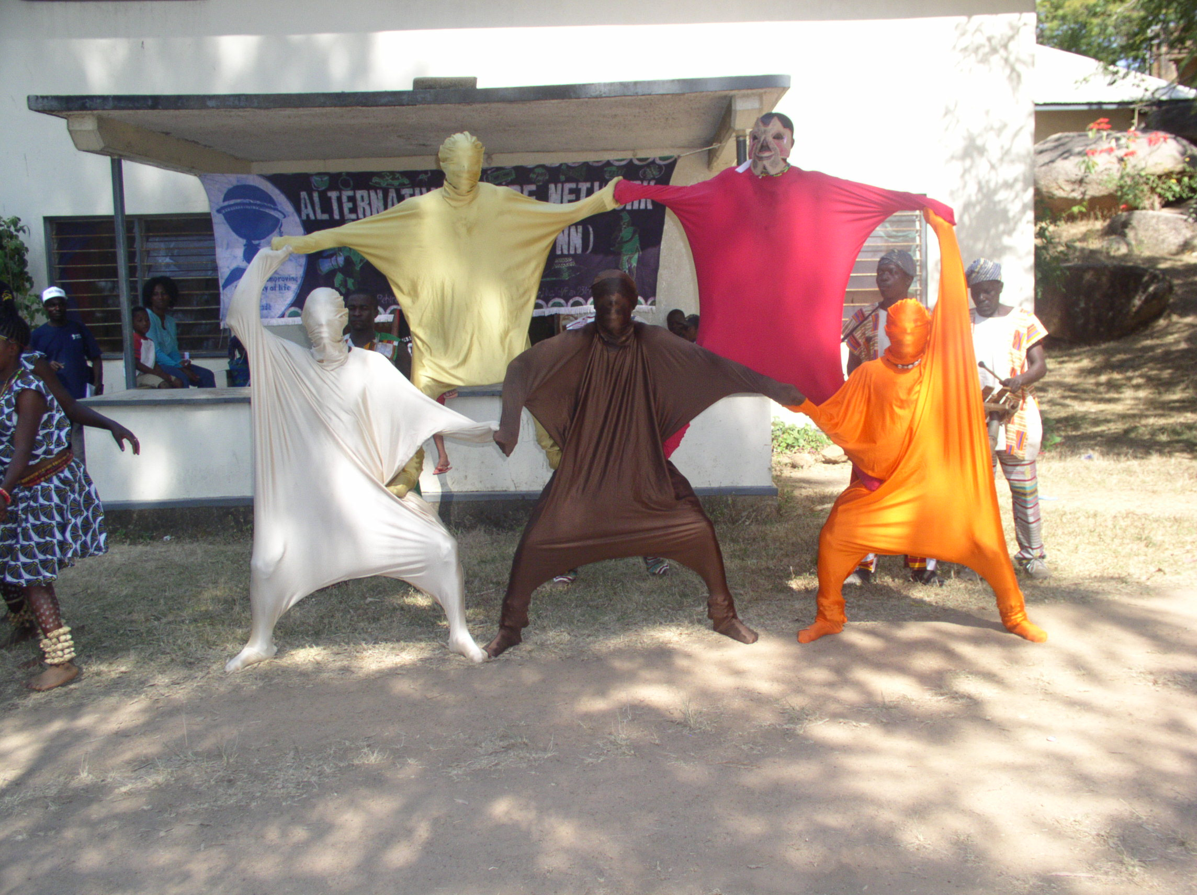
FTO costumes at Global Journey, Nigeria

NEWCASTLE: (Exact date to be confirmed)
EVENT: The ideas so far are to try and get the banner on board the Estelle and to hold a Fair Trade meal with a discussion of FTO’s.
20/04

CONTACT: stella.carmichael@newcastle.gov.uk
28/04

BRIGHTON: (Exact date to be confirmed)
12/05
EVENT: Brighton and Hove City Council wish to put on an event to welcome the Global Journey.

CONTACT: jnlivingstonedahu@yahoo.co.uk

Do you want to hold a Fair Trade V Free Trade debate in your town or university?

CELEBRATION IDEAS

A Carnival float

An imaginative journey- think earth, sea, sky

Setting off FTO balloons

Projecting the FTO mark onto a prominent building

Fair Trade Markets

Fundays

Marches

Demonstrations

Debates

World music events

Street theatre

Producer visits

Make and fly IFAT kites

Be inventive with the journey- how will you carry the banner? By bus, unicycle, tractor..?

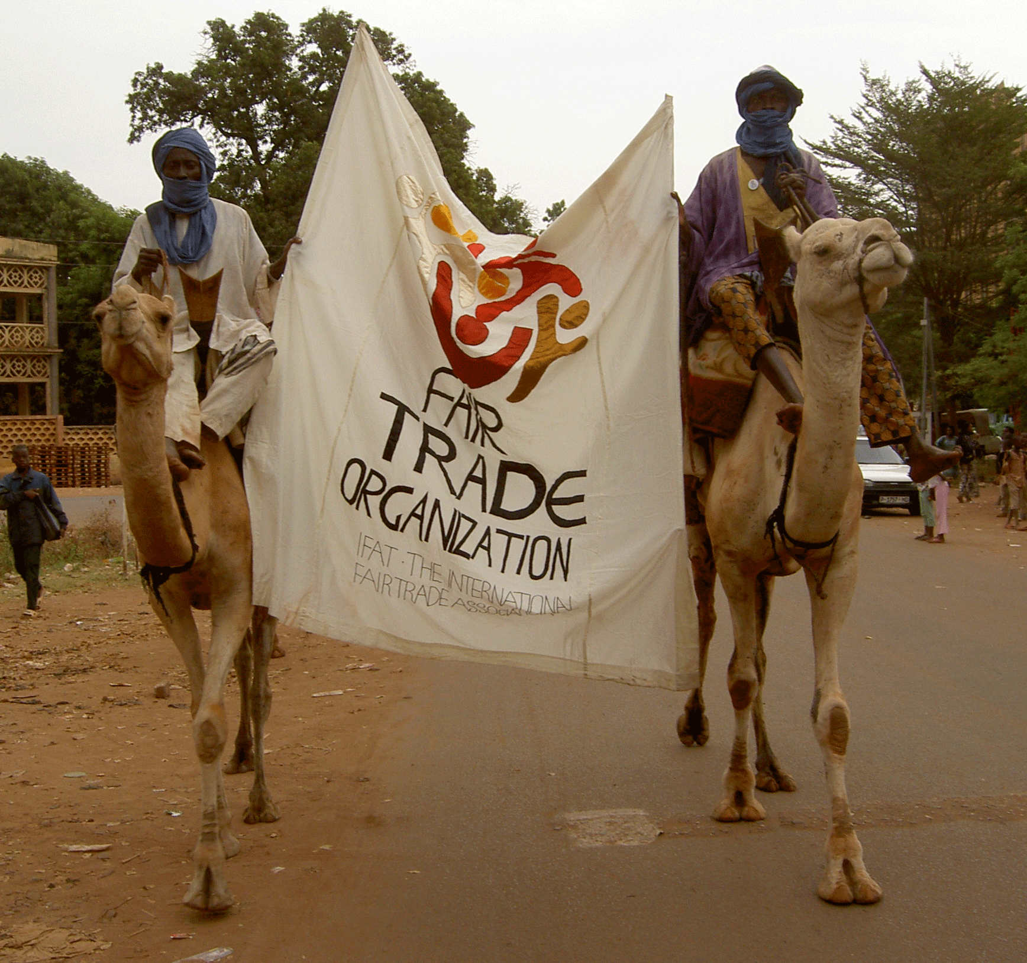
The Global Journey in Mali

Key Elements of Global Journey Events
1. Inform the Media: These events are newsworthy and deserve all the attention and interest and involvement we can generate.
2. Read the Global Journey Message: The Message will be read to the event gathering. Ideally, a notable person with connections to fair trade, equality, environmental respect, or social justice and empowerment will be invited to read the Message.

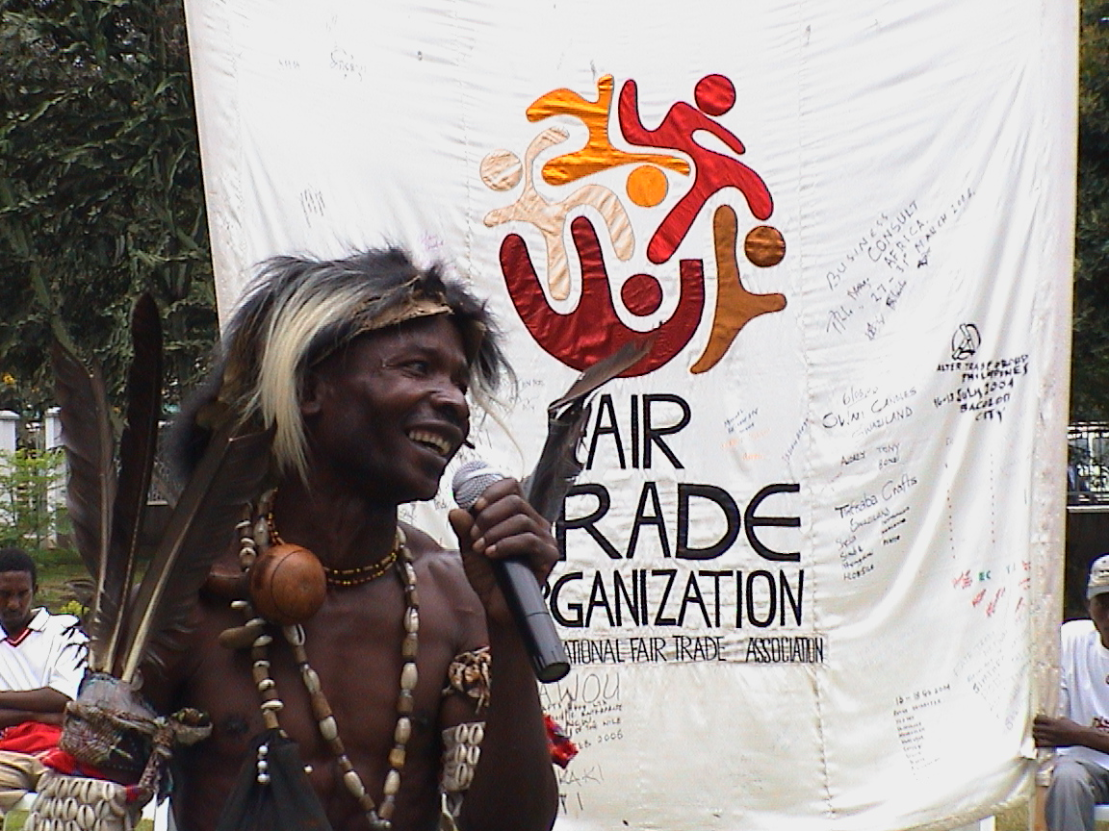
The Global Journey message being read in Tanzania

3. Display the Fair Trade
Banner: The large, colourful IFAT banner will be raised immediately after the Message has been read. The Flag will then be carried for all guests to see and ultimately it will be set-up at the Event to fly over all activities.
4. Celebrate! Have fun whilst promoting FAIR TRADE ORGANIZATIONS with the Global Journey.

RESOURCES

✰ Artwork for posters, placards and badges
✰ Guidelines for event (download from www.ifat.org)  The Message
✰ 5 x Costumes
✰ DVD of the Global Journey launch and footage of events worldwide
✰ PowerPoint presentation of Global Journey to use for Fair Trade groups
✰ Template for press releases  Information and advice on creating media interest  Information on organising a demonstration
✰ Translated Standards
✰ ‘What is.... ?’ Leaflet briefly detailing about the Global Journey, FTO Mark and IFAT (master copy available to print from)

If you would like to use any of these resources or have any questions about the Global Journey then email: ukglobaljourney@yahoo.co.uk

NEXT ISSUE
Please email in with any updates and progress of Global Journey events

How to target Global Journey events

How to get press attention Global Journey

Notice board for anyone to wants to send a message to the Global Journey group.

