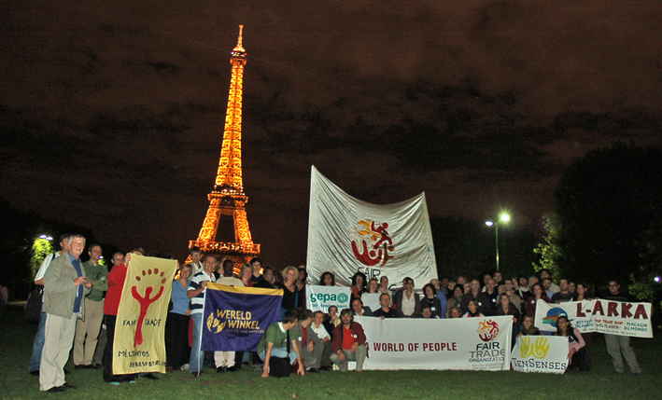
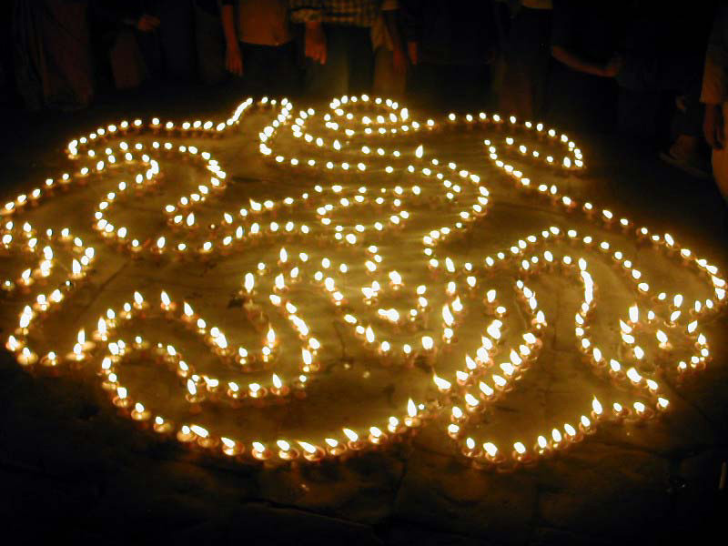
GLOBAL JOURNEY UK

Global Journey in Paris- Thomas Freteur

Welcome to the November edition of the Global Journey newsletter.
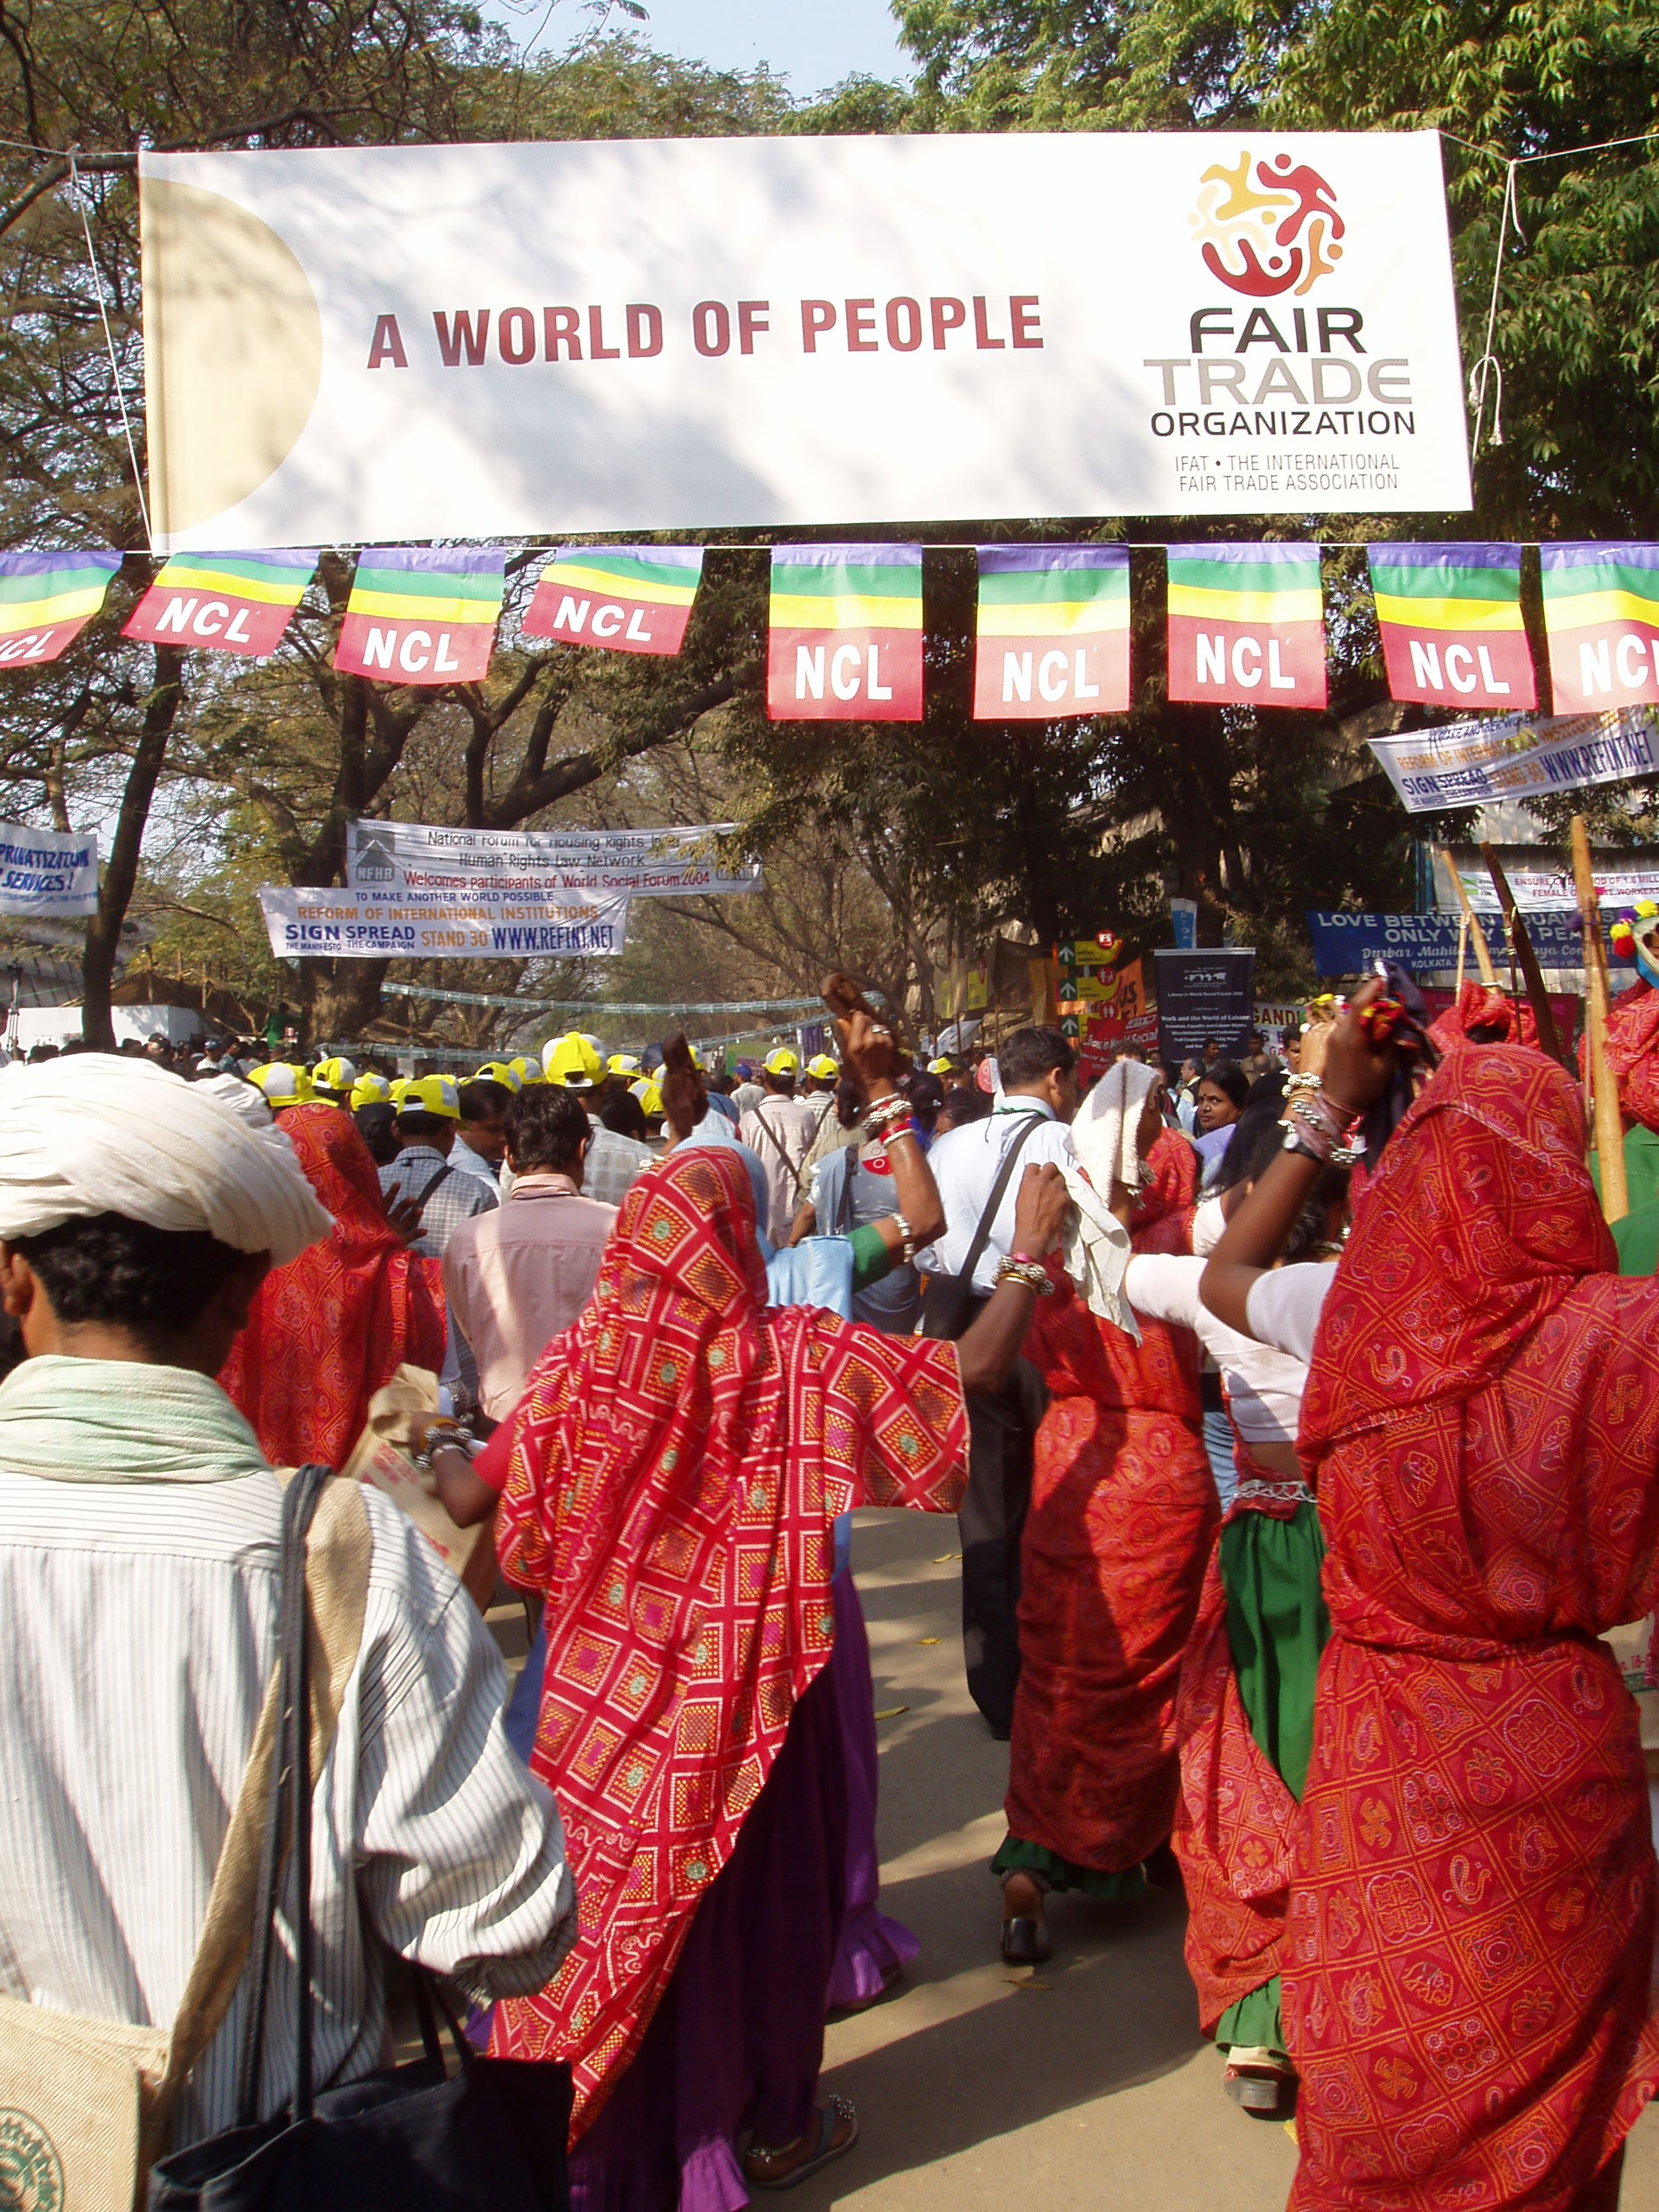
Global Journey in India
Since September’s newsletter the Global Journey banner has visited Sweden, the IFAT conference in France (see the above picture) and is currently on its way to Hungary!
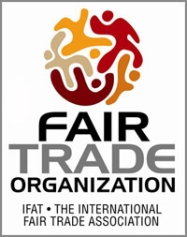
In this edition please find an update of Global Journey events planned across the country. There is already a brilliant line up of events so thank you everyone who has got involved! The dates are nearly all booked up so please get in contact if you would like to host the Global Journey banner or to change/ cancel your date.
The Global Journey is the world wide tour of the Fair Trade Organization Mark banner across 50 different countries. In each country IFAT members and Fair Trade supporters organise events to publicise and celebrate Fair Trade Organizations in the North and South.

New to November’s newsletter is the NOTICE BOARD section where FTO’s and Fairtrade groups can advertise upcoming events or use to message each other. There is also some advice on how to get press attention for your Global Journey event. If anyone has any good tips to share then please get in contact.

The Global

Journey

If you would like to send in something for the Notice board or have any questions, comments or ideas please email Kate at: ukglobaljourney@yahoo.co.uk
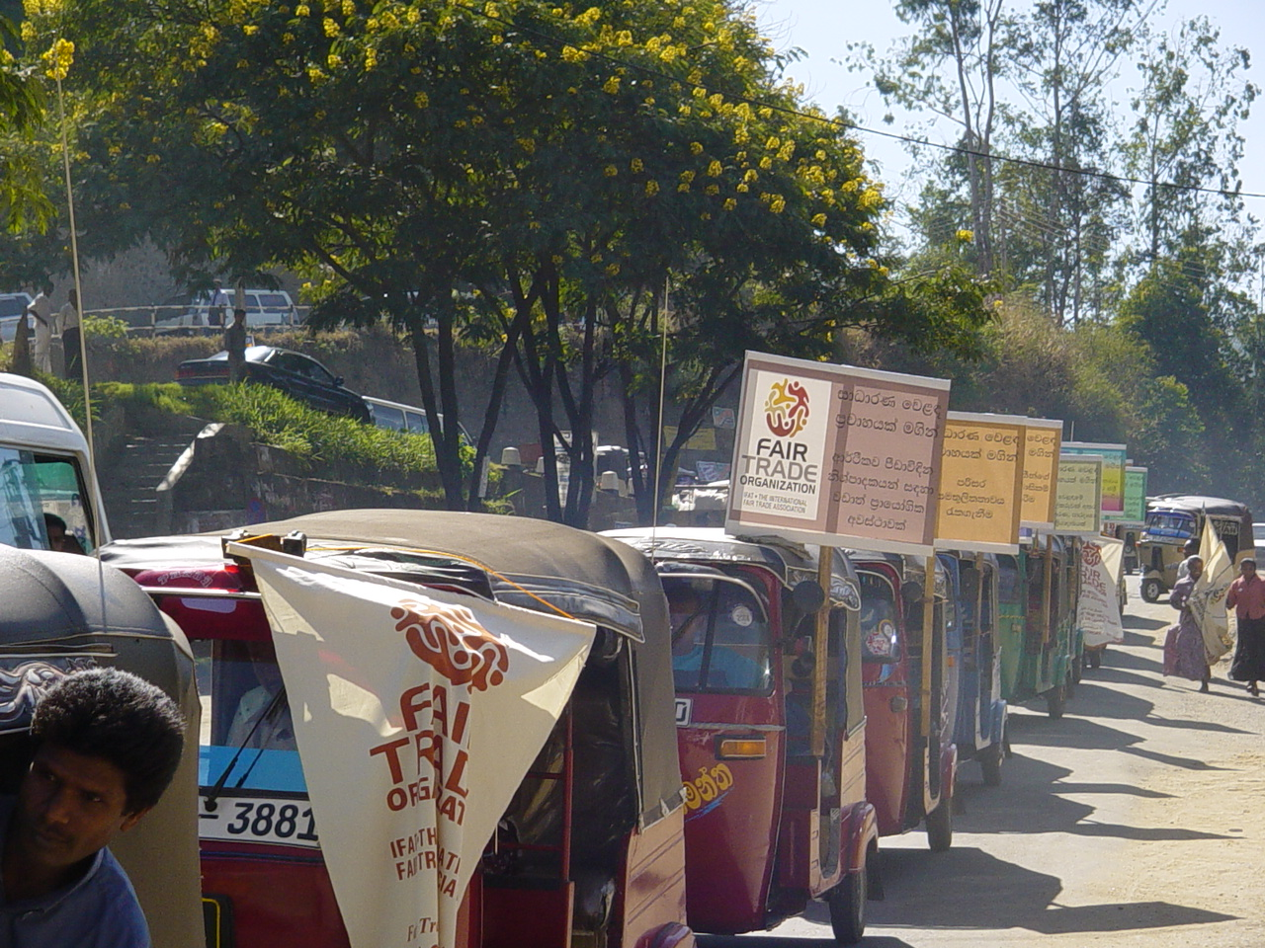

CALENDER OF EVENTS

This is where YOU all come in, the Global Journey is an excellent opportunity to: promote Fair Trade, Fair Trade Organizations and to show solidarity with the world wide Fair Trade movement.

Here are the dates that have already been booked with contact details. You are invited to join these events or add your own event.

3RD – 4TH March GLASGOW THE FAIR TRADE EXPERIENCE EVENT: Visit the IFAT stand and see the presentation on the Global Journey and join Global Journey procession around the event.

March: (first week of March)
THE ONE WORLD SHOP EDINBURGH
EVENT: The Global Journey banner to be paraded to the Scottish Parliament from a Fair Trade Breakfast. The Edinburgh group would like to link the vento Malawian producers.

CONTACT: Rachel on rfarey@oneworldshop.co.uk or 0131 229 4541

March: (dates to be set)
CARLISLE
EVENT: The Carlisle World Shop (BAFTS) and the Carlisle Fairtrade City Steering Group will host the Global Journey banner.

CONTACT: Lorna Strong on lorna.strong@rattenrow.co.uk

INTERESTED IN HOLDING AN EVENT?
PLEASE SEE THE MAP ON THE NEXT PAGE TO SEE WHEN THE GLOBAL JOURNEY IS IN YOUR AREA.
CONTACT KATE MEAKIN AT UKGLOBALJOURNEY@YAHOO.CO.UK
OR RING 07840 485344

14th April
IRELAND
EVENT: An event will be put on to celebrate the Global Journey.

17th April
Pachacuti
DERBYSHIRE
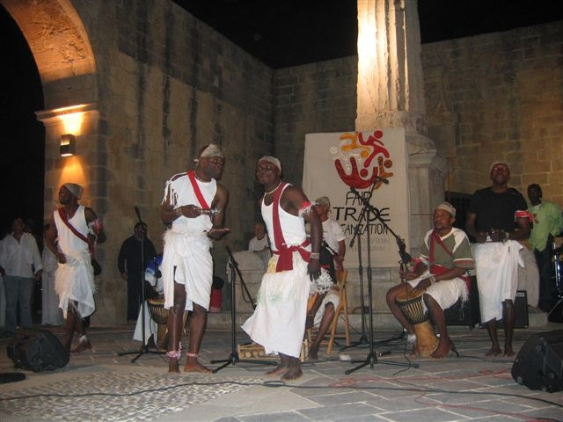
EVENT: Pachacuti, the Panama hat company wish to host the Global Journey banner.

Global Journey in Malta
18th April
NEWCASTLE
EVENT: The ideas so far are to try and get the banner on board the Estelle and to hold a Fair Trade meal with a discussion of FTO’s.

CONTACT: stella.carmichael@newcastle.gov.uk

20th April
YORK
EVENT: FAIR TRADE event in York School, with possible inclusion Archbishop Sentamu.

CONTACT: Jeremy at JP@sharedearth.co.uk
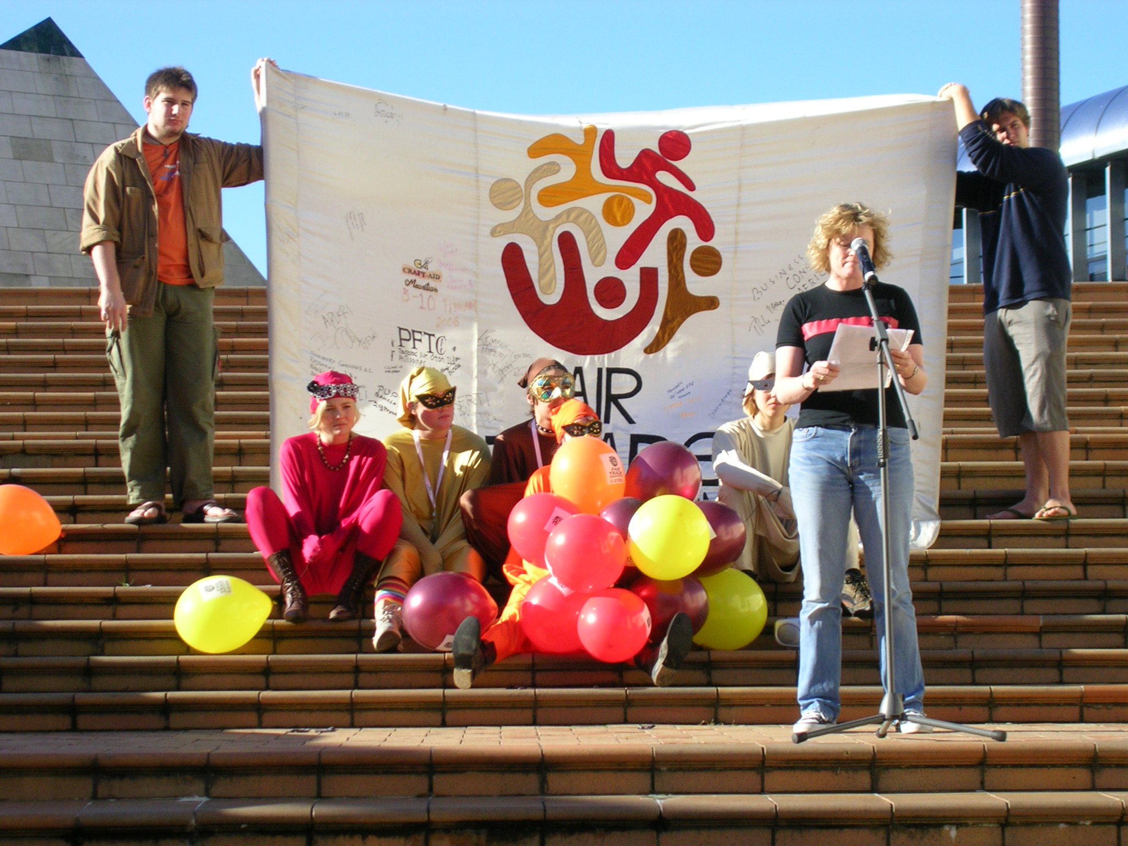
The Maori Message being read in Wellington

21st APRIL
HULL
EVENT: There will be a march from One World Shop to the Guildhall, to the Institute for abolition of slavery. The speech will be read in Queens garden or outside the law courts

CONTACT: Peter at peter@fairtradehull.org.uk

22nd – 23rd April
BRADFORD
EVENT: Bradford will host the Global Journey banner
CONTACT: John at dumelama2000@yahoo.co.uk

26th April
BRIGHTON
EVENT: BBC interested in showcasing the arrival of the banner. Suggestion that a church congregation might fund an African guest singer for the evangelical choir- ideally with dealings with a Fair Trade Cooperative. CONTACT:
jnlivingstonedahu@yahoo.co.uk

28th – 29th April
OXFORD
EVENT: Service at the Oxford University church, the Global Journey will be welcomed by one of the first Oxfam field directors in South India. A street play outside the Fair Trade Shop in the Cornmarket and Fair Trade coffee in the Vaults. The banner will then move on to Banbury.
MARCH:
EDINBURGH
18/04:
NEWCASTLE tbc
CONTACT: Carol at
21/04:
HULL
cwills@oxfordhr.co.uk

1st – 5th May:
WALES
EVENT: Three events are being planned in: South, Mid and North Wales to promote the Global Journey.
1/04 – 5/04:
WALES
There will be street theatre in Aberystwyth. Funding is being sought from the Welsh assembly for a debate.
28/04 -29/04:
OXFORD
8/04:
PLYMOUTH
Festivities will end with the Global Journey banner being Welsh folk danced to the Fairdo’s fashion show.
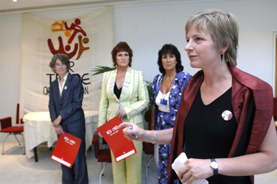
CONTACT: Kate at ukglobaljourney@yahoo.co.uk 07840 485344

NOTICE BOARD
The Wales Fair Trade Forum is holding a conference on 11th Novemeber in Newtown. There will be a host of different speakers about everything to do with Fair Trade- Including the Global Journey. See www.fairtradewales.com or email walesfairtrade@btconnect.comto book a place.

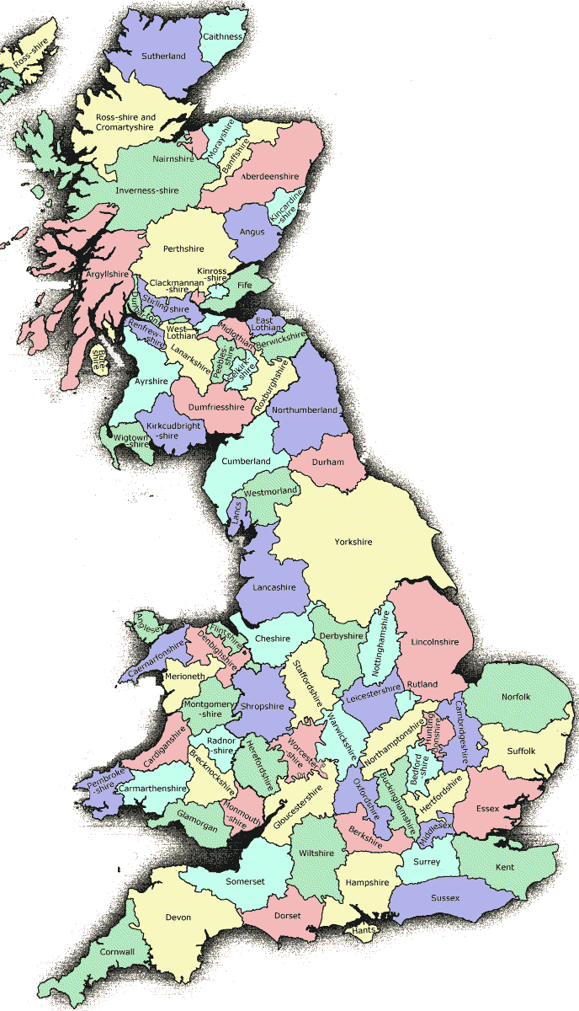

The European vote in Strasbourg
8th May
PLYMOUTH
EVENT: The Plymouth University group will host the Global Journey banner.
CONTACT: Michael at
michael.poole@students.plymouth.ac.uk

10th May
LONDON
EVENT: A joint event is being planned with the FTOs. Ideas so far include: a rally, rickshaws, a boat down the Thames and a red open top London bus, persuading politicians and journalists to come on board and discuss FTO’s. There is also discussion about holding another Free Trade V Fair Trade debate.
3/03 – 4/03:
GLASGOW
APRIL:
CARLISLE
20/04:
YORK
22/03 – 23/04:
BRADFORD
CONTACT: Kate at ukglobaljourney@yahoo.co.uk
NOTICE BOARD
There is a meeting open to all who want to get invclved in the London Global Journey. It will take place on 13th December at 2.30 in the Twin London office. To come along please contact UKGLOBALJOURNEY@YAHOO.CO.UK. We look forward to seeing you there!
10/04:
LONDON
26/04:
BRIGHTON

HOW TO GET MEDIA ATTENTION

The Global Journey message is all about promoting and raising awareness about Fair Trade, Fair Trade Organisations and Trade Justice.

The people we are trying to reach are:

Fair Trade Supporters- trade justice campaigners, fair trade customers, activists, ethical consumers. People who are interested in Fair Trade.

Fair Trade workers: people within Fair Trade Organizations: volunteers, staff employees, stall holders - each and every member of the organizations that we work with

It is important that people know what The FTO Mark is is, what it signifies and to promote the Fair Trade Organisation Global network.

Clients: trading partners, service suppliers, council buyers, procurement, company buyers- Do they know what an FTO is this is the opportunity to spread the word?.

Key Political and Social: people in the world of trade - key decision makers and politicians, leaders in the council We want the law to recognize Fair Trade Organizations. To do this we have to try and reach the politicians and activists. We also want the trade activist community to support and be aware of FTO’s

The FTO Mark is only awarded to organisations that have poverty reduction at the heart of what they do, differentiating them in the market place.

Enabling us to recognise FTOs who are mission-driven Organisations whose key objective is the eradication of poverty and so can be distinguished from conventional companies

The best way to get attention is either through an eye catching event or by using the newspaper, radio and TV. The easiest way is to send out a well written catchy press release in plenty of time. Local newspapers are always looking for stories and keen to support local events. There are also more and more ethical publications (including online journals) springing up. Read the publications to get an idea if your event/ story would fit in. Then tailor the media release accordingly.

It is also worth making contact with local radio and TV stations to see about doing an interview about Fair Trade in general and then talk about the FTO mark and your event.

I will be sending out a guide on how to write a press release shortly!

Next Edition

Please email in with any Global Journey updates.

The Noticeboard

Lessons from the Global Journey Globally

Global Journey facts and figures to use in publicity material

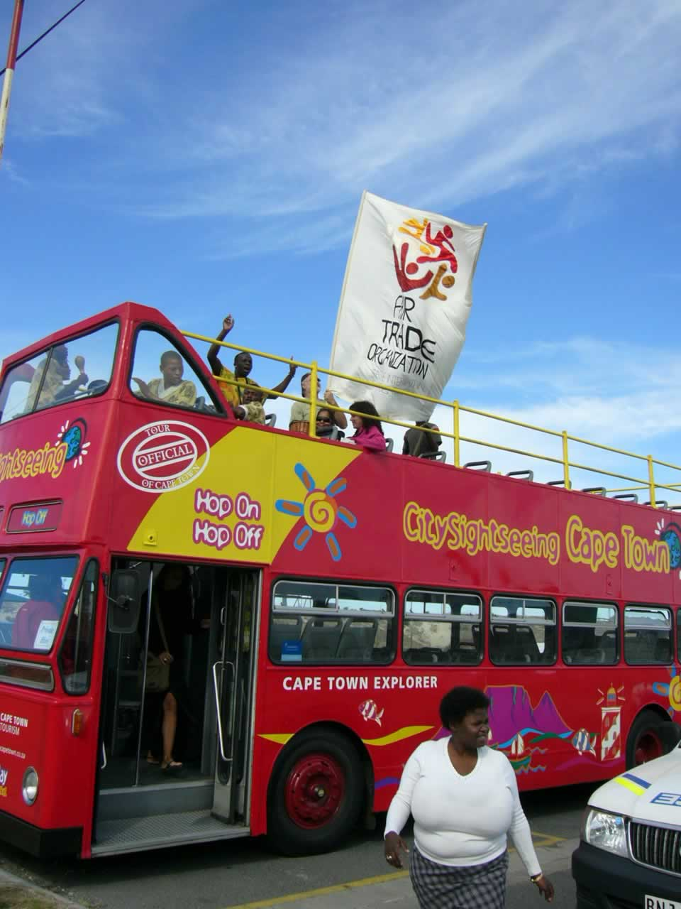

The Global Journey in South Africa

