Fair Trade – Definition
- Fair Trade is a trading partnership, based on dialogue, transparency and respect, that seeks greater equity in international trade. It contributes to sustainable development by offering better trading conditions to, and securing the rights of, marginalized producers and workers – especially in the South.

- Fair Trade organizations have a clear commitment to Fair Trade as the principal core of their mission. They, backed by consumers, are engaged actively in supporting producers, awareness raising and in campaigning for changes in the rules and practice of conventional international trade.

- Fair Trade is more than just trading: it proves that greater justice in world trade is possible. It highlights the need for change in the rules and practice of conventional trade and shows how a successful business can also put people first.

Fair Trade embraces two overlapping branches of endeavour.

Fair Trade Organisations

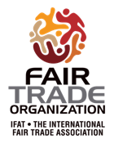
Organisations that exist purely for promoting Fair Trade may join the International Association for Fair Trade (IFAT), and adopt the Fair Trade Organisation Mark.
(Ref 1)

Hull One World Shop belongs to the British Association for Fair Trade Shops, which is a registered Fair Trade Organisation.

Hull One World Shop actively campaigns on behalf of marginalised artisans and farmers in the “South”.
(Ref 2)

Fair Trade labelled products

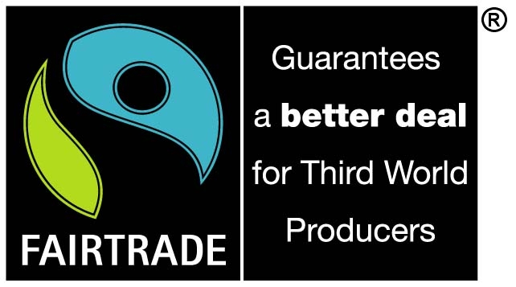
The FAIRTRADE mark is an independent consumer label which appears on products as an independent guarantee that disadvantaged producers in the developing world are getting a better deal.
For a product to display the FAIRTRADE mark it must meet international Fairtrade standards. These standards are set by the international certification body Fairtrade Labelling Organisations International (FLO). (Ref 3)
Fairtrade Labelling was created in the Netherlands in the late 1980s. The Max Havelaar Foundation launched the first Fairtrade consumer guarantee label in 1988 on coffee sourced from Mexico.
Today FLO co-ordinates Fairtrade Labelling in 20 countries including the UK.
There are over 2,000 Fairtrade retail and catering products available in the UK. Fairtrade products range from tea, coffee, chocolate, fruit, rice, to flowers, clothing and even footballs.
Hull and Fairtrade

The campaign to promote Fair Trade in Hull started in the 1970s with a small number of church based activists selling Tearcraft and then Traidcraft products. Hull One World Shop (Ref 2) was established in central Hull in 1994 and has grown in size and significance since that time. In December 2002 Hull One World Shop and Hull City Council joined forces to campaign for Hull to become a Fairtrade City. The project started in March 2003. (Ref 4)

Hull was awarded Fairtrade City status in March 2005. (Ref 4)
To become a Fairtrade city, town or village 5 goals must be met:
1. The local council must pass a resolution supporting Fairtrade, and serve Fairtrade coffee and tea at its meetings and in offices and canteens.
2. A range of Fairtrade products must be readily available in the area’s shops and served in local cafés and catering establishments (targets are set in relation to population).
3. Fairtrade products must be used by a number of local work places (estate agents, hairdressers etc) and community organisations (churches, schools etc).
4. Attract media coverage and popular support for the campaign.
5. A local Fairtrade steering group must be convened to ensure continued commitment to Fairtrade Town status.
The Hull Fairtrade City Project is sponsored by a partnership between Hull City Council and the One World Shop, Hull. Hull’s Fairtrade City Steering Group also includes people from the business community, from the churches and schools, and from the service community.(Ref 5).

Churches and schools can also achieve Fairtrade status. (Refs 6, 7).

Each March, along with the rest of the UK, Hull celebrates Fairtrade fortnight. From the 26th February to the 11th March there will be a number of projects and events happening across the city to raise awareness of Fairtrade and Hull’s commitment to it. (Ref 8).

This year will be especially significant for Hull as we prepare to be at the centre of the world’s commemorations for the Slave Trade Act which was passed 200 years ago in March. The Act was led by Hull’s MP at the time, William Wilberforce.

Slavery still continues today despite the work of Wilberforce. Fairtrade plays an important role in helping people to sustain a living and is seen as a modern day antidote to slavery. This is because Fairtrade buys direct from the producers who must meet set standards before their products can be branded with the Fairtrade logo.

The standards are:
- pay a price to producers that covers the costs of sustainable production and living;
- pay a 'premium' that producers can invest in development;
- make partial advance payments when requested by producers;
- sign contracts that allow for long-term planning and sustainable production practices

Benefits of Fairtrade include regular income, workers pay and conditions, cleaner environment, new housing and improved health and sanitation.

All of the benefits help people to plan for the future and live sustainable lives which reduce the chances of them having to seek a living by becoming involved in slavery.

For more information contact Martin Budd, Policy Officer on 01482 300 300 or visit:

1) www.ifat.org – International Fair Trade Association
2) www.oneworldhull.co.uk – One World Shop Website
3) www.fairtrade.org.uk – Fairtrade Foundation
4) www.fairtradehull.org.uk – Fairtrade City website
5) www.fairtradehull.org.uk/pages/about.htm – Fairtrade City Steering Group
6) www.tradejustice-yorkshirechurches.org.uk – Fairtrade Churches
7) www.oneworldhull.org.uk/schools/schools.htm – Fairtrade in Schools
8) www.fairtradehull.org.uk/campaigns/ft1407.htm – Fairtrade Fortnight

