Press Release 8th February 2010 - For immediate release.

HULL AND EAST YORKSHIRE GO BANANAS FOR FAIRTRADE.
Fairtrade fortnight starts on 22nd February with a visit from Nioka Abbott, a banana farmer from the Windward Islands. Bananas are Britain’s most popular fruit, and the vast majority of households buy them every week. 1 in every 4 bananas sold in UK is a Fairtrade banana and Fairtrade bananas are available throughout the region. Nioka’s visit will give lots of people the chance to learn more about bananas and the reasons they should buy Fairtrade bananas.

Peter Church, joint co-ordinator of the Fairtrade City Project in Hull, will accompany Nioka as she visits as many as possible of the Fairtrade Towns in the area to emphasise how important Fairtrade is to her farming communities in the Windward Islands. The extra money earned through the Fairtrade System helps to provide education and community facilities that could not otherwise be afforded.

Fairtrade Farmer visits to UK are co-ordinated nationally by the London based Fairtrade Foundation. The foundation has made great strides in promoting Fairtrade, and the brand is now very widely recognised. All the major supermarkets stock Fairtrade labelled products (including bananas) and every one of the bananas sold by Sainsbury’s carries the Fairtrade label. Many major corporations are adopting Fairtrade as a standard including Tate and Lyle (sugar), Cadbury’s (Chocolate) alongside the Fairtrade organisations such as Agrofair (Fruit) Divine Chocolate, Café Direct (hot beverages), Liberation Nuts, Traidcraft and Equal Exchange.

There are now hundreds of Fairtrade Towns in the UK, and the movement is spreading throughout Europe and America.

Nioka will be touring widely in Yorkshire during Fairtrade Fortnight, and starts in Beverley with a visit to FERN, the Fairtrade East Riding Network, at Toll Gavel Church. Following Beverley, Nioka will be travelling to the Fairtrade Towns of Malton, Pickering and Scarborough Borough, talking to schoolchildren, shoppers, and church people about banana farming and Fairtrade.

Back in Hull later in the week, Nioka will be visiting Southcoates Primary School before an evening in the Guildhall entitled “Fairtrade is Bananas”. The evening is hosted by Hull City Council and sponsored by The Co-operative Group and Hull One World Shop. Following Nioka’s presentation, a highlight of the evening is a comedy slot by “Just Fair Laughs”, and presented by Fairtrade Comedians: Jo Enright, Mundo Jazz and Tony Vino. This is the first ever Fairtrade Comedy night in the region, and will include a “best joke” competition.

Full details of all local Fairtrade Fortnight events are at: www.fairtradehull.org.uk/pages/2010.htm.

Peter Church

[ends]

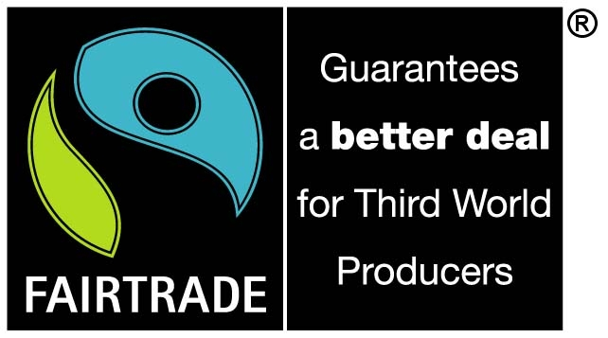


Profiles and background:

Nioka Abbott-Balcombe.
- member of WINFA’s board of directors,
- secretary of the Executive Committee of the SVGFTO (St Vincent & the Grenadines Fairtrade Organistation, a WINFA member),
- Vice -chair of its Trading arm, WINFARM INVESTMENTS.

Banana farmers in St Vincent took over the exporting of bananas recently through WINFAMR INVESTMENTS, giving them greater control over their business. This blog post gives more information.

There are a number of very current challenges facing the banana industry going to the core of trade justice and the WTO/EU, especially in the Caribbean, and it sounds as if our visitor will be well placed to communicate these issues- along with the benefits of Fairtrade- to audiences in Yorkshire.

Peter Church:

Fairtrade activist since 1982, based in Hull and is jointly responsible for the Fairtrade City Project. Contact details below.

Christine Church:

Fairtrade activist since 1982, based in Hull and is the Director responsible for the Hull One World Shop, the mainstay of Fairtrade in the region. Contact details below.

Fairtrade Foundation briefing paper on bananas: http://preview.tinyurl.com/yaqagqg

For more information contact:

Fairtrade Foundation:
www.fairtrade.org.uk
Fairtrade Foundation, Room 204, 16 Baldwin's Gardens, London EC1N 7RJ
tel: +44 (0)20 7405 5942 | fax: +44 (0)20 7405 5943 | mail@fairtrade.org.uk

Hull City Council:
www.hullcc.gov.uk
Councillor Thomas, 01482 614842, Councillor.Thomas@hullcc.gov.uk
Hull City Council, Guildhall, Alfred Gelder Street, Hull . HU1 2AA

Hull Fairtrade City Project
www.fairtradehull.org.uk
Peter Church 01482 446402, peter@fairtradehull.org.uk
Fairtrade City Project, c/o Central Methodist Hall, Kind Edward Street, Hull. HU1 3SQ.

Hull One World Shop
www.oneworldhull.co.uk
Chris Church, 01482 327727. info@oneworldhull.co.uk
One World Shop, c/o Central Methodist Hall, Kind Edward Street, Hull. HU1 3SQ.

