Photocall Notice | 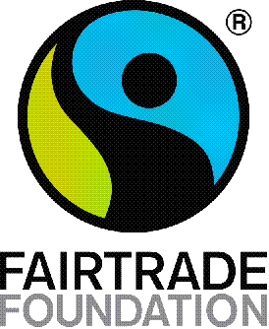

Yorkshire Makes their FAIRTRADE Mark in Hull with giant logo

DATE & TIME:
12:00
Saturday 5th October 2019

LOCATION:
Trinity square, Hull

WHAT:
Over 150 people will meet at Trinity Square and stand in the shape of the familiar Fairtrade Mark.

The Mark will be created by the Fairtrade Yorkshire Group of 38 Fairtrade places as a human mosaic. Volunteers including some of Hull’s Absolutely Cultured volunteers and Fairtrade campaigners from around the region dressed in the iconic colours of blue, green and black will form the Fairtrade mark.

There will also be stalls inside Trinity Market Hall from local businesses selling fair trade food and crafts. The stalls will be open 10-4.

The giant recreation of the Mark symbolises the unity and support of the Fairtrade movement in Yorkshire to fight the injustice in the world and exploitation of the farmers and workers who provide the food and products we consume every day. Other similar Marks will be taking shape in five locations across the UK from Cornwall to Scotland.

WHO:
Celebrities in attendance at the photocall will include:
Local MPs:
Members of the community: The Lord Mayor

Joanna Pollard, Co-ordinator of Fairtrade Yorkshire and Peter Church, of Faith in Fair Trade, Hull will be available for interview on the day.

The 25th anniversary is also being supported by a host of other celebrities including Adjoa Andoh, Allegra McEvedy, Martin Morales, Tom Hunt, Asma Khan.

WHY:
From 4th – 7th October Fairtrade is celebrating its silver anniversary, 25 years of the Mark in the UK and 25 years of support from thousands of businesses, campaigners and consumers.

The Fairtrade Mark is recognised by 9/10 people in the UK and in five different regions, Cornwall, Wales, York, Scotland and London, there will be similar Fairtrade Marks appearing at well-known locations. This moment of unity will show strength and solidarity for the farmers and workers who struggle daily to earn a living income to feed their families, send their children to school and create a safe and secure home.

Fairtrade has transformed the lives of over 1.6 million farmers in 73 different countries and as we celebrate 25 years this autumn, we look to the next 25 years. Poverty and inequality are the root causes of some of the biggest challenges today like migration and the climate crisis and to care for our planet we must care for its people.

The Fairtrade mark was the first ethical label and has become the most well known and most trusted one in the UK because it delivers more value back to farmers than any other.

Alongside this exciting recreation of the FAIRTRADE Mark there will be hundreds of events organised, from bake-sales to talks to school assemblies.

Find out about the Fairtrade 25th anniversary here: https://www.fairtrade.org.uk/get%20involved//Current-campaigns/Fairtrade-at-25

-Ends -

For more information please contact emily.mccoy@fairtrade.org.uk / 07467373981

